**Master Functional Document**

|  |  |
| --- | --- |
| **Application** | NGERP - Centra |
| **Service Bundle** | Master Management |
| **Service Request** | Manage Scheduler |

**Description :**

The scheduler master is used to run the scheduler and to keep log of the Database jobs start and end time.

**Workflow Process :**

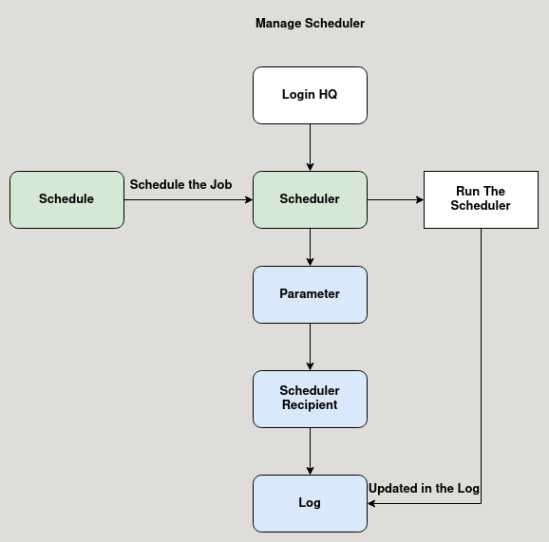

Business Rules :

* Click test run to run the Database job, after the job completed it shows success message.
* A schedule is mapped to the scheduler master to run the job at specific time and day.
* Either the job is success or failure, user can check the details in the log tab.
* The scheduler recipient tab is used to map user to with email alert about the job status is sent.